Multiples
# Source: AI Source: Provided by: [Data Path: Persons Table -> ID Column: 1, Name_En Column: Motasem Essam] -> From: [ChatGPT] on [7/13/2026]
Multiples are numbers obtained by multiplying a given number by an integer. They form one of the fundamental concepts in arithmetic and elementary number theory and are closely related to divisibility, factors, prime numbers, greatest common divisors (GCD), and least common multiples (LCM).
Every nonzero integer has infinitely many multiples.

Definition
# Source: AI Source: Provided by: [Data Path: Persons Table -> ID Column: 1, Name_En Column: Motasem Essam] -> From: [ChatGPT] on [7/13/2026]
A multiple of an integer $a$is any number that can be written in the form
$$m=a×k$$
where:
- $a$is the given number
- $k$is an integer
- $m$is a multiple of $a$
Equivalently,
$$a∣m$$
which means $a$divides $m$.

Terminology
# Source: AI Source: Provided by: [Data Path: Persons Table -> ID Column: 1, Name_En Column: Motasem Essam] -> From: [ChatGPT] on [7/13/2026]
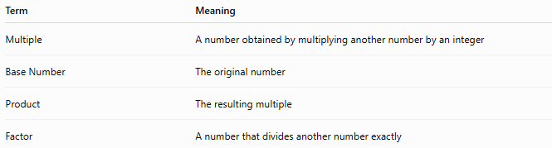
Term | Meaning
Multiple | A number obtained by multiplying another number by an integer
Base Number | The original number
Product | The resulting multiple
Factor | A number that divides another number exactly

Rules for Multiples

1. Every Number Is a Multiple of Itself
# Source: AI Source: Provided by: [Data Path: Persons Table -> ID Column: 1, Name_En Column: Motasem Essam] -> From: [ChatGPT] on [7/13/2026]
Since
$$a=a×1$$
every integer is a multiple of itself.
Example
$$12=12×1$$
Therefore,
$$12$$
is a multiple of
$$12$$

2. Zero Is a Multiple of Every Integer
# Source: AI Source: Provided by: [Data Path: Persons Table -> ID Column: 1, Name_En Column: Motasem Essam] -> From: [ChatGPT] on [7/13/2026]
Since
$$0=a×0$$
for any integer $a$,
$$0$$
is a multiple of every integer.
Example
$$0=7×0$$
Therefore,
$$0$$
is a multiple of
$$7$$

3. Multiples Continue Forever
# Source: AI Source: Provided by: [Data Path: Persons Table -> ID Column: 1, Name_En Column: Motasem Essam] -> From: [ChatGPT] on [7/13/2026]
Every nonzero integer has infinitely many multiples.
Example
Multiples of
$$5$$
are
$$5, 10, 15, 20, 25, 30,…$$

4. A Multiple Is Divisible by the Original Number
# Source: AI Source: Provided by: [Data Path: Persons Table -> ID Column: 1, Name_En Column: Motasem Essam] -> From: [ChatGPT] on [7/13/2026]
If
$$m=a×k$$
then
$$a∣m$$
Example
$$42=6×7$$
Therefore,
$$42$$
is a multiple of
$$6$$
and
$$6∣42$$

5. Common Multiples Can Exist
# Source: AI Source: Provided by: [Data Path: Persons Table -> ID Column: 1, Name_En Column: Motasem Essam] -> From: [ChatGPT] on [7/13/2026]
Two or more numbers may share the same multiple.
Example
Multiples of
$$4 \\ 4, 8, 12, 16, 20, 24,…$$
Multiples of
$$6 \\ 6, 12, 18, 24, 30,…$$
Common multiples:
$$12, 24, 36,…$$

Types of Multiples

1. Positive Multiples
# Source: AI Source: Provided by: [Data Path: Persons Table -> ID Column: 1, Name_En Column: Motasem Essam] -> From: [ChatGPT] on [7/13/2026]
Multiples generated using positive integers.
Example
Multiples of
$$3 \\ 3, 6, 9, 12, 15,…$$

2. Negative Multiples
# Source: AI Source: Provided by: [Data Path: Persons Table -> ID Column: 1, Name_En Column: Motasem Essam] -> From: [ChatGPT] on [7/13/2026]
Multiples generated using negative integers.
Example
Multiples of
$$3 \\ -3, -6, -9, -12,…$$

3. Common Multiples
# Source: AI Source: Provided by: [Data Path: Persons Table -> ID Column: 1, Name_En Column: Motasem Essam] -> From: [ChatGPT] on [7/13/2026]
Multiples shared by two or more numbers.
Example
Common multiples of
$$2$$
and
$$5$$
are
$$10, 20, 30, 40,…$$

Examples
# Source: AI Source: Provided by: [Data Path: Persons Table -> ID Column: 1, Name_En Column: Motasem Essam] -> From: [ChatGPT] on [7/13/2026]
Example 1
List the first six multiples of
$$4 \\ 4, 8, 12, 16, 20, 24$$

Example 2
List the first five multiples of
$$7 \\ 7, 14, 21, 28, 35$$

Example 3
Determine whether
$$36$$
is a multiple of
$$9$$
Since
$$36=9×4$$
the answer is yes.

Example 4
Determine whether
$$50$$
is a multiple of
$$8$$
Since
$$50÷8$$
does not produce an integer,
$$50$$
is not a multiple of
$$8$$

Example 5
Find the common multiples of
$$3$$
and
$$5$$
First few multiples:
$$3, 6, 9, 12, 15, 18, 21, 24, 27, 30,… \\ 5, 10, 15, 20, 25, 30,…$$
Common multiples:
$$15, 30, 45,…$$

Example 6
Find the first four multiples of
$$12 \\ 12, 24, 36, 48$$

Multiples Table
# Source: AI Source: Provided by: [Data Path: Persons Table -> ID Column: 1, Name_En Column: Motasem Essam] -> From: [ChatGPT] on [7/13/2026]
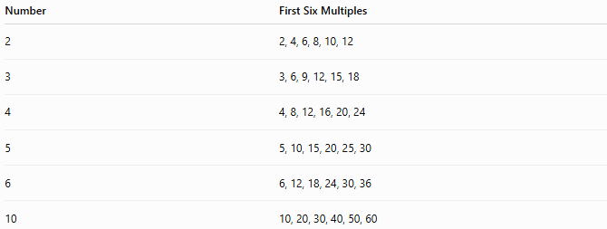
Number | First Six Multiples
2 | 2, 4, 6, 8, 10, 12
3 | 3, 6, 9, 12, 15, 18
4 | 4, 8, 12, 16, 20, 24
5 | 5, 10, 15, 20, 25, 30
6 | 6, 12, 18, 24, 30, 36
10 | 10, 20, 30, 40, 50, 60

Finding Multiples
# Source: AI Source: Provided by: [Data Path: Persons Table -> ID Column: 1, Name_En Column: Motasem Essam] -> From: [ChatGPT] on [7/13/2026]
To find multiples of a number:
- Start with the given number.
- Multiply it by:
$$1, 2, 3, 4,…$$
- Continue as needed.
Example
Multiples of
$$8 \\ 8×1=8 \\ 8×2=16 \\ 8×3=24 \\ 8×4=32$$
Therefore:
$$8, 16, 24, 32,…$$

Real-Life Applications
# Source: AI Source: Provided by: [Data Path: Persons Table -> ID Column: 1, Name_En Column: Motasem Essam] -> From: [ChatGPT] on [7/13/2026]
Multiples are used in:
- Scheduling
- Manufacturing
- Inventory management
- Engineering
- Computer science
- Music rhythms
- Calendar calculations
- Event planning
- Construction
- Mathematics education

Real-Life Examples
# Source: AI Source: Provided by: [Data Path: Persons Table -> ID Column: 1, Name_En Column: Motasem Essam] -> From: [ChatGPT] on [7/13/2026]
1. School Bell Schedule
A bell rings every
$$15$$
minutes.
Ring times occur at multiples of
$$15$$
minutes:
$$15, 30, 45, 60,…$$

2. Bus Timetables
A bus arrives every
$$20$$
minutes.
Arrival times are multiples of
$$20$$
minutes.

3. Manufacturing
A machine produces
$$12$$
items per cycle.
After several cycles:
$$12, 24, 36, 48,…$$
items are produced.

4. Music
Musical patterns often repeat after a number of beats that are multiples of a base rhythm.

5. Calendar Events
Events occurring every
$$7$$
days follow multiples of
$$7$$
days.

6. Computer Programming
Loops and algorithms frequently check whether a number is a multiple of another number.

Common Mistakes
# Source: AI Source: Provided by: [Data Path: Persons Table -> ID Column: 1, Name_En Column: Motasem Essam] -> From: [ChatGPT] on [7/13/2026]
- Confusing multiples with factors.
- Forgetting that multiples continue infinitely.
- Assuming every larger number is a multiple.
- Ignoring zero as a multiple.
- Mixing common multiples with common factors.

Key Points
# Source: AI Source: Provided by: [Data Path: Persons Table -> ID Column: 1, Name_En Column: Motasem Essam] -> From: [ChatGPT] on [7/13/2026]
- Multiples are obtained by multiplication.
- Every integer has infinitely many multiples.
- Zero is a multiple of every integer.
- Every number is a multiple of itself.
- Common multiples are shared by two or more numbers.
- The smallest positive common multiple is the LCM.

Factors vs. Multiples
# Source: AI Source: Provided by: [Data Path: Persons Table -> ID Column: 1, Name_En Column: Motasem Essam] -> From: [ChatGPT] on [7/13/2026]
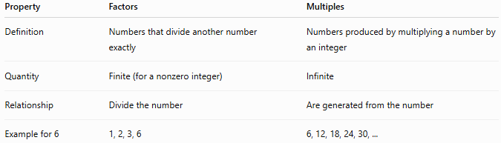
Property | Factors | Multiples
Definition | Numbers that divide another number exactly | Numbers produced by multiplying a number by an integer
Quantity | Finite (for a nonzero integer) | Infinite
Relationship | Divide the number | Are generated from the number
Example for 6 | 1, 2, 3, 6 | 6, 12, 18, 24, 30, ...

Conclusion
# Source: AI Source: Provided by: [Data Path: Persons Table -> ID Column: 1, Name_En Column: Motasem Essam] -> From: [ChatGPT] on [7/13/2026]
Multiples are numbers obtained by multiplying a given integer by another integer. They are fundamental to arithmetic and number theory, helping describe patterns, divisibility relationships, common multiples, and least common multiples. Multiples appear throughout mathematics and have practical applications in scheduling, engineering, manufacturing, computing, and everyday problem-solving.

